**Extended Project Qualification**

An investigation of Howard Shore’s use of musical devices in his score for The Lord of the Rings

By Nathan Guth

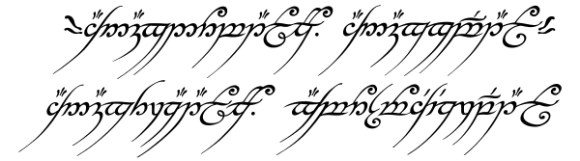

[1]

# Abstract

This document can be printed. However, it is strongly recommended to read or have a digital copy available, as with it will be supplied the audio and video tracks referenced to many times throughout this report.

Whilst they are not necessary to complete the reading of this paper, having access to them will greatly aid in the understanding of the topics discussed in this paper.

All audio extracts are provided in .FLAC format. This common audio file type can be read and processed by most modern media players (VLC, Windows Media Player, etc.…) and on most operating systems.[2]

All video extracts are provided in .MP4 format. This common video file type can be read and processed by most modern media players (VLC, Windows Media Player, etc.…) and on most operating systems. [3]

**All audio and video tracks are being used for educational and instructional purposes only. The author of this EPQ does not own any of the media distributed with this project and is not profiting from them in any way. All rights go to the respective artists and authors, which are credited to at the end of this document**

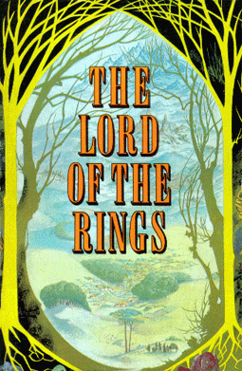

[4]

# Introduction

This Extended Project Qualification will be tending to the subject of film music, and in particular the work of Howard Shore, the Canadian composer who wrote, orchestrated and produced the music of the film trilogy *“The Lord of the Rings”* by Peter Jackson.

This project aims to explore the works created by Howard Shore for The Lord of the Rings trilogy and to examine his composition. By evaluating techniques and methods he made us of, this report aims to create an understanding of their use and effectiveness in advancing the story-telling and atmosphere of The Lord of the Rings by Peter Jackson. By using transcripts of scores, official commentary and external sources and opinions, this project will serve as a demonstration of how a thematic approach to composing a score for a picture can be carried out, and how it was effectively done by Howard Shore.

This topic was chosen as the joint subject of both music, in particular film music, and the study of movies in general. From this mix came the decision to study the effect of film music in movies, and how the composer uses his work to add to the narrative on screen.

WHY CHOSEN TOPIC (POWERPOINT)

LEAD TO TITLE

HOW WILL CONCLUDE? (TITLE)

# 2 Howard Shore’s Score

## **2.0 The Lord of the Rings**

*The Lord of the Rings* is an epic work of fiction written by John Ronald Reuel Tolkien between 1937 and 1949. Since its first publication, it has become the best-selling novel of all time[5], and has accumulated worldwide fame and popularity as one of the greatest works of fiction ever written.

The Lord of the Rings film trilogy was released from 2001 to 2003. Produced almost entirely in New Zealand, it is a faithful and accurate adaptation of the novels, with minor story and pacing changes to suite the story better to the big screen. Many agree that no franchise in the history of film making was as meticulously and carefully planned. The many years of production and coordination that were spent at the end of the 1990’s created one of the most critically acclaimed collection of films[6].

The work of Peter Jackson and his dedicated crews and teams enthralled the many fans of Tolkien’s work, but his well-adapted films and techniques engaged and touched a much wider audience too.

During the theatrical releases of each film, an extended version was also released for each movie. These extended cuts contained up to 45 minutes of extra footage and music, as well as behind the scenes commentary and interviews. Due to the increase in run time and musical material, this study will be focusing on the Extended Edition of each respective film, and will be ignoring the differences between the theatrical and extended cuts.

The Lord of the Rings, Theatrical Releases:

2001 The Fellowship of the Ring

2002 The Two Towers

2003 The Return of the King

The Lord of the Rings, Extended Editions:

2002 The Fellowship of the Ring Extended Edition

2003 The Two Towers Extended Edition

2004 The Return of the King Extended Edition

## **2.1 The Story**

To tell the story of *The Lord of the Rings* in a few words is to skip and compress nearly all of Tolkien’s work. However, to understand the significance and context of some of the plot points and use of music in the films, one would benefit in having some knowledge of the series of events that unfold in all 3 books of *The Lord of the Rings.*

The start of the first book sees us introduced to The Shire and its inhabitants the Hobbits, of which we learn of a few in particular. Bilbo Baggins is the 111 year old uncle of Frodo Baggins, who live together in Bag End. After celebrating his 111th birthday, Bilbo departs from the Shire after leaving his magic ring to Frodo, all of this being of great interest to the wizard Gandalf the Grey, a friend of Bilbo’s and regular visitor to the Shire. After seeking council from his elder, Saruman the White, another wizard, Gandalf concludes that this ring is the long lost Ring of Power of the dark lord Sauron, who is rising again in the land of Mordor in the east. Sauron cannot rise to his full strength without the Ring of Power however, as part of his soul is attached to the object.  
Gandalf therefore sets Frodo on a quest to Rivendell, city of the Elves, along with 3 other hobbits Sam, Merry and Pippin, who are chased by the 9 servants of Sauron, the Ringwraiths. After many perils and encountering a ranger named Strider, the Hobbits make it to Rivendell. There, called by Elrond, lord of Rivendell, a secret gathering of representatives of the races of Middle Earth is held, where the fate of the Ring is decided upon. This council, the council of Elrond, is where the Fellowship of the Ring is created; whose mission is to destroy the Ring in the fires of Mount Doom, in the heart of Mordor. There, Strider’s heritage as the heir to the throne of men is revealed, and that he is Aragorn, last of a long-lost line of Kings.  
After Saruman betrays the free peoples of Middle Earth, he sends orcs after the Fellowship. Being forced to cross ancient dwarven mines Gandalf dies fighting a demon of old ages. The Fellowship escapes, but is then split up after another of its members, Boromir is killed. From there, Frodo and Sam are left alone to destroy the ring, and the remaining members are caught in the war between Men and the forces of Isengard, Saruman’s kingdom. Gandalf is brought back from the dead by greater powers, and sent to Middle Earth as Gandalf the White, to complete his task of securing the peace. After helping men triumph over Saruman’s forces, Gandalf convinces Rohan, a large state under the rule of King Théoden, to ride to the aid of Gondor, another kingdom of men under attack by Sauron and his forces. After many battles and perils, Frodo and Sam destroy the Ring just in time to save the armies of men. Aragorn is crowned king of Gondor, and the Hobbits return to their Shire.

This is the main story arc followed by The Lord of The Rings, and all 3 movies stay faithful to it. The majority of changes the films had to make were to omit certain details, scenes and stories from the novels, as they were simply too long and detailed to put to screen entirely.

[7]

## **2.2 Howard Shore’s Score**

When Peter Jackson and the creative team behind TLORT films were preparing for the task of filming three pictures back to front in 1999, he asked Fran Walsh, a writer and producer of the trilogy, to lay in a ‘temp track’ over the rough cut of animated sequences and story boards of all three films[8]. A temp track is a temporary mock-up of a film’s soundtrack, assembled from pre-existing music prior to the real, commissioned score being composed and recorded[9].  
  
This is common practice when preparing production for a movie[10], and has been used in cinema for a very long time[11]. It allows the director to have guidelines for the mood, atmosphere and pacing of scenes, all without the need to have music pre-composed, as it is too early in the making process to do so. Temp tracks are then replaced with the composed soundtrack later. It was during this selection process that Peter Jackson found himself drawn to Howard Shore’s previous works, including *‘The Silence of the Lambs’, ‘Ed Wood’* or *‘The Fly’.*

The Canadian composer Howard Shore, notable for his film scores, has composed over his career more than 40 soundtracks. His work on The Lord of The Rings trilogy earned him his first Oscar, as well as a Grammy, a Golden Globe nomination and a BAFTA[12].

Anyone who has delved into the novels written by JRRT, whether it be *The Lord of the Rings, The Hobbit* or *The Silmarillion*, is aware that they are much more than stories and novels, but that Tolkien has created within them an alternate world. This feat of world building has led to the development of one of the most detailed, complex and rich universe of fiction containing cultures, historical accounts of these cultures, relationships between various lands and species, and a clear account of the functionings of these lands.

The soundtrack referred to in this project is known as the Complete Recordings. With each film released an official theatrical soundtrack, each a single-disk album, was also published. However, while these contained many of the tracks used in the films, they were cut-down and very short in comparison to the scale of the works used in the pictures. That is why, in 2005, after much popular demand, official soundtracks were released, known as the Complete Recordings. These multi-disk albums totalled nearly 10 hours of soundtrack, the vast majority used in the films. Included with these soundtracks were official annotated scores, commentary and information about the composition process written by Doug Adams[13].

The Fellowship of the Ring - 3 CDs (total 180:35)

The Two Towers: - 3 CDs (total 188:13)

The Return of the King: - 4 CDs (total 228:17)

Total: 598:05 or 9hrs 58mins

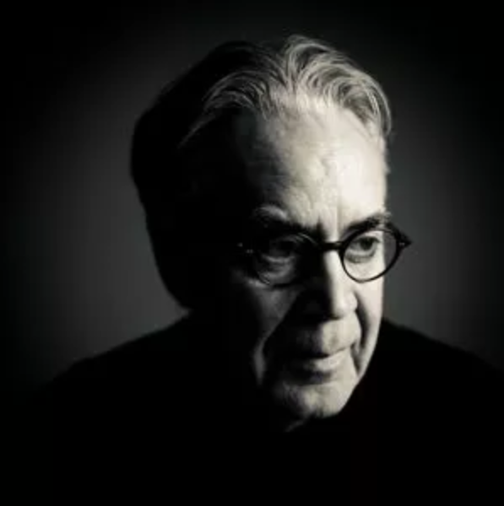The volume of the Complete Recordings allows for much more detailed inspection of the progression of themes and motifs, and being able to speak of the music that was used directly in the pictures allows for greater study of its effectiveness the films. As the majority of the Theatrical Soundtracks is included as part of The Complete Recordings, this project will focus on the contents of the Complete Recordings, and ignore the differences between the two releases of TLORT soundtracks.

By the time Shore had finished scoring the films, he had written over 10 hours of continuous music, with themes for nearly every character presented in the movies, in addition to multiple motifs for some of the lands, some for nature, and themes for the ring of power.

In total, more than 70 individual themes can be heard throughout the soundtrack, with many having variations on their main motifs. [14]

## **2.3 Primary Research: Doug Adams**

CHANGE ADAMS TO SECONDARY

ADD TO RESEARCH METHODS

DIFFICULTY

ADD PRIMARY SECTION

## **i. On the work of Doug Adams**

When Howard Shore began his work composing for *The Lord of the Rings*, he looked into documenting the process and work he was about to go through. His mind turned to Doug Adams, a musical journalist that had he had already become aware of. Shore noted “His work consistently stood out”[15]. As a result, when Shore started his work, he invited Adams to write an article documenting the work on *The Fellowship of the Ring.*

During the 4 years that it took Shore to create a musical image of the books by JRR Tolkien, Adams followed that process during the entire period. As Howard Shore studied the books, watched the films and composed, Doug Adams was continuously keeping track of Shore’s work.

After the trilogy was completed and released, and the soundtracks officially published however, it became important to Shore that the score should be organized, and that a comprehensive view of the music was made. It was then that Doug Adams agreed to write this comprehensive account.[16]

*“The Music of The Lord of the Rings: A comprehensive account of Howard Shore’s Score”* is the results of nearly 10 years of work from Doug Adams. The more research Adams did, the more Shore gave him access to his archives – sketches, scores, notebooks, recordings, film and videos. From 2001 to 2010 Adams absorbed and organized the years of work by listening to recordings, and studying the scores. The produced book is an account of all those findings, and includes snippets of scores, as well as a CD containing disused themes and recordings, as well as interviews with Howard Shore.

During the research of this EPQ, it was important to have many and varied sources of information. However, above all else, primary sources are of most value when looking for detail and truthful information. That is why this report by Doug Adams was used as the primary source of information regarding the scores by Howard Shore. Due to Adams working very closely with Shore for such a long period of time, this source can be considered to be the ‘last word’ on any conflicting or non-matching pieces of information. Having found many other studies on the music and sonic space of *The Lord of the Rings*, none of them were found to be as detailed and specific as *The Music of The Lord of the Rings*.

# 3 A Study of Leitmotifs

## **3.0 The Leitmotif**

The Leitmotif, from German meaning ‘leading motive’[17] is a recurring musical theme or idea.  
To this definition should be added the role of the leitmotif, which is the main reason for their use and popularity. The leitmotif is used to reinforce dramatic action, suggest to the listener further ideas relevant to the narrative, and to provide further insight and complexity to characters, places, notions, events or even objects.  
All of this is achieved through using various musical techniques to modify themes and motifs, in order to mirror or add to whatever is happening on screen. By combining and altering themes together, the composer can use the audience’s perception of these changes to great effect.

This technique of attaching particular themes to parts of a narrative was not born from cinema however. Their most prominent and famous use is in opera. Partially attributed to Richard Wagner, the leitmotif was also effective in the performance of live music on stage. Since the advent of the modern cinema, a film’s soundtrack has gradually grown to become one of the most power tools for storytelling in a director’s belt.

## **3.1 The Shire [SECTION INCOMPLETE]**

### **i. The Story Briefly**

The Shire is the homeland of Hobbits. Located northwest of the realms of men, elves and dwarves, its inhabitants are virtually unknown to the common folk, and only those who travel or who are well learned in these lands are aware of the existence of Halflings, or Hobbits.  
Hobbits are ancient mortal beings that are small and short. Most live longer than men, a race some believe Hobbits are connected to. The average lifespan of a Hobbit is thus around 100 years. Smaller than Dwarves (between 2 and 3 feet high), Hobbits are skilled listeners, with good eyesight, and are a quite nimble kind.  
Their love of craftsmanship and farming means they prefer to settle down permanently, rather than have large ambitions. Their kind is not one to go to war. They keep to themselves, enjoy the peace created, and rarely go out and exploring on adventures.

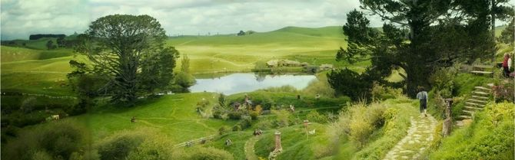Figure 1The Fellowship of the Ring’s depiction of the Shire

Often compared to the midlands of England, the Shire is a green and flourishing region, where farmlands prosper. Throughout the narrative of TLOTR, the Shire is greatly associated with the themes of peace, prosperity, and most importantly, of home.  
It is from the Shire that Frodo, Sam, Merry and Pippin begin their journey, and they would not come to see it again until the very end of the War of the Ring. This notion of home is often brought up throughout the struggles and perils these Hobbits encounter during their adventures, and their purpose is often described as ‘saving’ the Shire and all they love from the doom of Mordor.

### **ii. Motifs**

As a prominent part of the narrative, the theme of the Shire is perhaps one of the most recognisable, most well-known and loved theme composed by Howard Shore.

Due to the connection between the Hobbits and their homeland, the theme in question serves as both a motif for the Hobbits, and the actual physical location that is the Shire as well as the feelings and emotions it represents during the story’s unfolding.

The Shire is one of the first themes introduced to the audience in *The Fellowship of The Ring.*

Here is the theme representative of The Shire:

Figure 2The Shire



*Strings in unison with slow orchestral backings*

*D Major Tonality indicated by the F# and C#s*

The tune is heart-warming, comforting and inviting. It is easily relatable to the theme of home that is so often brought up in the story. The melody’s D Major tonality remains mostly in the major mode throughout the entire trilogy, and represents the ideal home that The Shire Represents. This theme has many sub-motifs devised from it, one can count as many as 15 variations on the same base melody and accompaniment.

## **3.2 The Fellowship [SECTION INCOMPLETE]**

### **i. The Story Briefly**

The Fellowship of the Ring is a group of representative of the different races of Middle-Earth. Appointed at the Council of Elrond, a secret gathering of the foes of Mordor, its mission was to protect and aid Frodo Baggins in his task as the ring-bearer, as he set out to destroy the one ring in the fires of Mount Doom, thus ending Sauron’s dominion of Mordor and destroying the threat to peace. This group of Men, Elves, Dwarves, Hobbits and a Wizard formed a great friendship during their perils together, and the narrative of TLOTR follows the adventures of its members as they are split up and eventually reunited through a series of great perils and adventures.  
There are nine members in the Fellowship:

* 4 Hobbits
  + Frodo Baggins
  + Samwise Gamgee
  + Meriadoc (Merry) Brandybuck
  + Peregrin (Pippin) Took
* 2 Men
  + Aragorn (Strider) Elessar
  + Boromir, son of Denethor II
* 1 Elf
  + Legolas, son of Thranduil
* 1 Dwarf
  + Gimli, son of Gloin
* 1 Wizard
  + Gandalf the Grey (Later Gandalf The White)

Elected to represent all the races present at the Council of Elrond, the Fellowship of the Ring represents the union, bonding and friendship of the group that the story revolves around. Howard Shore made sure to represent this in his work regarding the Fellowship.

PICTURE HOLDER  
Shot of tfotr at the council of Elrond

### **ii. Motifs**

As detailed before, the entire story of *The Lord of the Rings* revolves around the adventures of the members of the Fellowship. It comes to no surprise then that this theme is very prominent, and is heard many times throughout the trilogy. Its modifications are used to reflect the state of the Fellowship at different points during the story, and Howard Shore does this very effectively.

The development of the theme of the Fellowship is perhaps the most complex and interesting of all the main motifs written by Shore.  
The Fellowship is, as previously mentioned, a group of individuals. These characters are introduced in chronological order, in the novels as well as the films, and all come together in the same place and at the same time, the famous Council of Elrond, to be united in a common purpose.  
As such, the theme of the Fellowship sees itself very slowly introduced and developed over time, as the number of members of the Fellowship grows slowly as the story progresses. This build-up of thematic material peaks at the Council of Elrond, and after that is used to reflect the state of the Fellowship in the remaining 2 movies.

In fact, Elrond himself does not utter the words

*“So be it, you shall be The Fellowship of the Ring”[18]*  
Track 3.2.iii.00 Elrond creates the Fellowship

to the 9 companions until 1h 45 mins 30 seconds through the first movie, or exactly 46% of the total running time (3h48mins 11 seconds).

This leaves ample opportunity and great lengths of time for Shore to thematically develop the theme of the Fellowship prior to its creation, and to adapt it to any circumstance the characters of the Fellowship go through.

The theme for the Fellowship makes more than 20 separate appearances in the first film alone[19], therefore we will study here only some of the many cases this theme is used in the soundtrack for *The Fellowship of the Ring.*

SCORE TRANSCRIPT HOLDER  
The main theme of The Fellowship

ADD SECTION

THE FELLOWSHIP SOUNDING AT THE COUNCIL OF ELROND WITH THE MINOR VERSION MAY THE BLESSINGS OF MEN< ELVES AND THE FREE PEOPLE

## **3.3 Gondor and the Realms of Men [SECTION INCOMPLETE]**

### **i. The Story Briefly**

Gondor is the name of one of the oldest and most prominent kingdoms in Middle-Earth. Much of the second novel is set in it, as well as nearly the entirety of the third book.

Gondor’s height in power was during its early years

PICTURE HOLDER  
Map of Gondor

PICTURE HOLDER  
Shot of Minas Tirith

### **ii. Motifs**

As nearly all of the narrative in *Return of the King* revolves in and around the lands of Gondor, Howard Shore made sure to give this theme the importance, stature and prominence to match the kingdom it represents. Heard throughout nearly all of this film, it and its variations are found in many different ranges, instrumentations and characteristics.

Here is the theme that represents the realm of Gondor.

Track 3.3.ii.01 Gondor’s theme

This theme is first heard in *The Fellowship of the Ring* during the council of Elrond. It is played on a lonely trombone whilst Boromir, son of the Steward of Gondor, talks about his father.

As a first exposure to the audience, Shore makes sure that we associate this motif with the realm of Gondor, and with its people. As Boromir displays his dedication to his people and his family, we hear this clear brass theme, tarnished with sorrow and lament; Gondor is not what it used to be. It has fallen into ruins under the rule of the Stewards.

Once the theme begins to occur more consistently, it becomes clear that the music of Gondor receives its own special treatment in *The Lord of the Rings*. As so much of the story depends on the rule of the king, the return of the glory of men in Middle Earth, and the fight against evil, Shore has put much attention and detail in the way the music of Gondor evolves over the 3 films.

The melody exists in two separate settings, each of which beings identically, but go on to end differently. Gondor is first seen and spoken of as a fading society, a once glorious kingdom besieged by enemies from the outside, and crippled by poor leadership from within. Here, The Realm of Gondor finds its melodic climb turn downwards, and this creates the variation of Gondor in Decline.  
SCORE AND MUSICAL EXAMPLE – SHOW FIRST AND SECOND HALVES  
In *Return of the King*, Gondor struggles to reclaim its proper position governing Middle Earth. Though the path is rough and arduous, throughout the film Gondor does eventually re-establish its prominence in the world. This climb towards greatness is shown throughout the entirety of the third film, and peaks at the end, with the crowning of Aragorn, new King of Gondor in the Fourth Age of Middle Earth.

It is the Gondor in Ascension setting of the base theme that represents this protracted return to power. This setting of Gondor does not being to enter the score only after Gandalf and Pippin pass into the realm to warn Gondor of the impending attack from Mordor, thus directing the story’s final events towards this kingdom and its rise.

SCORE AND MUSICAL EXAMPLE – SHOW FIRST AND SECOND HALVES

Notice the second half of this theme. It is built off the first three pitches of the Fellowship’s theme.  
  
SCORE AND EXAMPLE – FELLOWSHIP AND GONDOR

This draws a connection between the Fellowship’s mission and its impact upon Gondor.

### **iii. In Scene**

As Gondor plays such a vital role in the third film, it is very often heard throughout its entire soundtrack. As a result of this, there are nearly a dozen instances of the theme being modified in some way to suit the scene, or to add elements to it.

As the music of Gondor is the central most theme *to Return of the King*, it is the one that plays when the opening title is displayed on screen. Due to the length of the film, this does not actually happen until 9 minutes and 50 seconds from the start of the movie. However, the build up to it and setting of the scene already gives insight into Gondor, the concluding story that is about to unfold, and sets the tone for this final and third act of The Lord of the Rings.

During this scene Aragorn, Gimli, Gandalf and Legolas accompanied by riders of Rohan make their way through the woods as the Fellowship themes out. As the camera tilts back the *Return of the King* title card appears, the theme shifts and French horns intones the opening of the Realm of Gondor theme. The Fellowship theme is incomplete; as is the company we see riding through the forest. It serves to let the audience quickly recognize the members of this company we have so often heard this theme associated with. But, this third and final movie’s focus is not on this Fellowship, or at least not directly. This is why the horns very quickly embrace the theme of Gondor, yet with uncertainty, and not glory and pride like some other renditions of the same theme; the war is not over, and the greatest challenges are yet to be faced by Gondor.

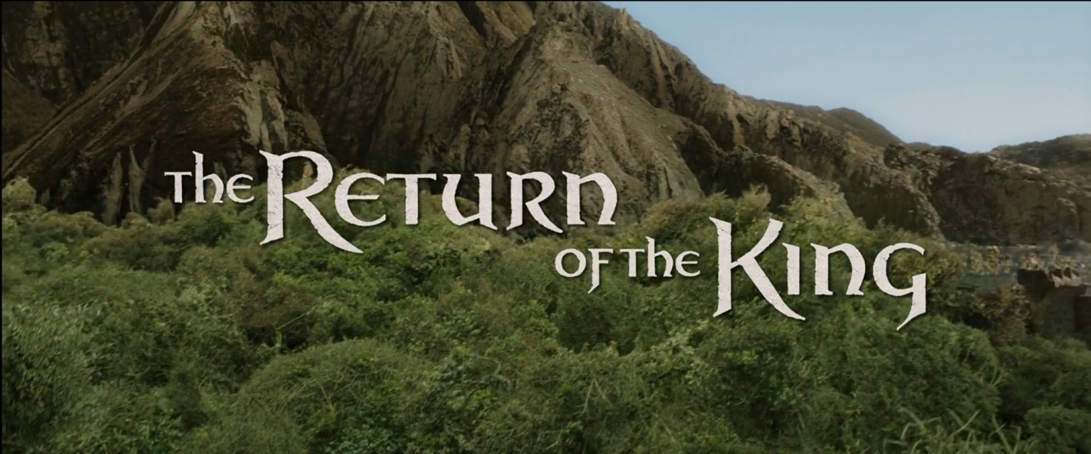Figure 3 the Return of the King title card

Track 3.3.iii.001 The Title screen soundtrack

The first extract of this theme given earlier (GIVE REFERENCE) is heard at the council of Elrond. It is played in the background to Boromir, the only man from Gondor at the council, as he describes his people’s struggle against the dangers faced by Gondor.

*“Long has my father the steward of Gondor kept the forces of Mordor at bay. By the blood of our people are your lands kept safe. Give Gondor the weapon of the enemy. Let us use it against him”[20]*  
Track 3.3.iii.002 Boromir saying this at the council of Elrond

Here we hear again, played on long and tender trombones, the theme of Gondor in decline. We make a connection with this land that Boromir speaks so passionately about. Gondor may be in decline, but they remain proud, and brave in the face of the armies of Mordor. Boromir’s plea to the council to let them use the Ring of Power is poignant. This is the first instance of the Gondor in Decline theme ever heard.

However, Gondor is not the main focus of the story until the third film begins. Consequently, the motif is heard but very rarely in *The Fellowship of the Ring* and in *The Two Towers*. However, it becomes the de facto theme for the third film, whose story develops within in greatly. This is why we do not get further development of this theme until the third movie.

Here is the first instance of the Gondor in Ascension theme being heard. It occurs when Gandalf and Pippin, two members of the Fellowship, travel on horseback to Gondor, bringing words of warning against the impending attack on the capital city of Gondor, Minas Tirith.

The Fellowship is yet to reach Minas Tirith; many of its members are far away. However Gandalf and Pippin are charging towards it. An excited, muscular Fellowship theme presses the duo across Middle Earth until, by the crossing of a stream, they pass into the borders of Gondor.  
As we here this, Gandalf announces the following:

“We’ve just passed into the realm of Gondor”  
Track 3.3.iii.003 Gandalf saying this to Pippin

Horns and strings quickly announce their arrival with a proud summoning of the main theme of Gondor. This reinforces this theme’s association with Gondor, only this time portraying the kingdom and its city is a more positive light. It sets the base theme that will be prominent throughout the entire third theme. Shore described this instance of the theme as “quite stately, and it is played on the brass. … It has a bit of a feeling of grandeur to it”[21].

# 4 Conclusion

# Bibliography & Filmography

Adams, D., 2010. *The Music Of The Lord Of The Rings.* s.l.:Alfred Music.

CouncilOfElrond, n.d. *CouncilOfElrond.* [Online]   
Available at: http://www.councilofelrond.com/  
[Accessed 04 2019].

Empire Online, n.d. *Best Movies.* [Online]   
Available at: https://www.empireonline.com/movies/features/best-movies/  
[Accessed 2019].

epicsound, n.d. *The Relevance Of Temp Tracks.* [Online]   
Available at: https://www.epicsound.com/resources/temptracks/

lotr score analysis project, n.d. *Lord of the Rings Score Analysis Project.* [Online]   
Available at: http://www.melson.nl/lotr/index.php  
[Accessed 2019].

lotr.fandom, n.d. *https://lotr.fandom.com.* [Online]   
Available at: https://lotr.fandom.com/wiki/Ring-inscription  
[Accessed 2019].

New Line Productions, n.d. *The Lord of the Rings - Soundtrack.* [Online]   
Available at: http://www.lordoftherings-soundtrack.com/  
[Accessed 2019].

Sadoff, R. H., 2006. *The role of the music editor and the 'temp track' as blueprint for the score, source music, and scource music of films.* s.l.:s.n.

Sadoff, R. H., 2006. The Role of the Music Editor and the 'Temp Track' as Blueprint for the Score, Source Music, and Scource Music of Films. *Popular Music,* 25(2), pp. 165-183.

*The Lord of the Rings: The Fellowship of the Ring Extended Edition.* 2002. [Film] Directed by Peter Jackson. s.l.: New Line Cinema.

*The Lord of the Rings: The Return of the King Extended Edition.* 2004. [Film] Directed by Peter Jackson. s.l.: New Line Cinema.

*The Lord of the Rings: The Two Towers Extended Edition.* 2003. [Film] Directed by Peter Jackson. s.l.: New Line Cinema.

The Star, 2007. *Tolkien Proves he's still the king.* [Online]   
Available at: https://www.thestar.com/entertainment/2007/04/16/tolkien_proves_hes_still_the_king.html  
[Accessed 2019].

Wikipedia, 2019. *List of accolades recieved by The Lord of the Rings film series.* [Online]   
Available at: https://en.wikipedia.org/wiki/List_of_accolades_received_by_The_Lord_of_the_Rings_film_series  
[Accessed 2019].

Wikipedia, n.d. *Leitmotif.* [Online]   
Available at: https://en.wikipedia.org/wiki/Leitmotif#cite_note-3  
[Accessed 2019].

Wikipedia, n.d. *The Lord of the Rings.* [Online]   
Available at: https://en.wikipedia.org/wiki/The_Lord_of_the_Rings  
[Accessed 2019].

# Abbreviations

PJ Peter Robert Jackson

JRRT John Ronald Reuel Tolkien

HS Howard Leslie Shore

TLORT The Lord of the Rings

TFOTR The Fellowship of the Ring

TTT The Two Towers

ROTK Return of the King

1|1|1 *title* [00:00 – 00:30] Film 1, CD 1, track 1 *title of track* from 00:00 to 00:30  
Used as referring The Complete Recordings

Contents

Abstract 2

1 Introduction 3

2 Howard Shore’s Score 4

**2.0** **The Lord of the Rings** 4

**2.1** **The Story** 5

**2.2** **Howard Shore’s Score** 6

**2.3** **Primary Research: Doug Adams** 8

**i.** **On the work of Doug Adams** 8

**3.0** **The Leitmotif** 9

**3.1** **The Shire [SECTION INCOMPLETE]** 10

**i.** **The Story Briefly** 10

**ii.** **Motifs** 11

**3.2** **The Fellowship [SECTION INCOMPLETE]** 12

**i.** **The Story Briefly** 12

**ii.**  **Motifs** 13

**3.3** **Gondor and the Realms of Men [SECTION INCOMPLETE]** 15

**i.** **The Story Briefly** 15

**ii.**  **Motifs** 16

**iii.**  **In Scene** 17

4 Conclusion 20

Bibliography & Filmography 21

Abbreviations 22

List of Figures [SECTION INCOMPLETE] 25

# List of Figures [SECTION INCOMPLETE]

Figure 1The Fellowship of the Ring’s depiction of the Shire 10

Figure 2The Shire 11

Figure 3 the Return of the King title card 17

For any questions, requests or inquiries, please immediately contact

Nathan Guth  
[guth.nathan@gmail.com](mailto:guth.nathan@gmail.com) or [guth.nathan@st-georges.lu](mailto:guth.nathan@st-georges.lu)  
Candidate number: 1717  
Centre number: 74252

1. Image credits: (lotr.fandom., n.d.)
2. Please contact the centre or author of this EPQ for any inquiries about reading any necessary audio/video files provided with this project. Contact information will be provided at the end of this document.
3. See footnote 1
4. Image credits: (Wikipedia, n.d.)
5. (The Star, 2007)
6. (Empire Online, n.d.)
7. Image credits: (lotr.fandom, n.d.)
8. (Adams, 2010, p. xii)
9. (Sadoff, 2006)
10. (epicsound, n.d.)
11. (Sadoff, 2006, pp. 165-183)
12. (Wikipedia, 2019)
13. (New Line Productions, n.d.)
14. Image credits: (HowardShore.com, n.d.)
15. (Adams, 2010, p. xi)
16. (Adams, 2010, p. xi)
17. (Wikipedia, n.d.)
18. (CouncilOfElrond, n.d.)
19. (lotr score analysis project, n.d.)
20. (The Lord of the Rings: The Fellowship of the Ring Extended Edition, 2002)
21. (The Lord of the Rings: The Return of the King Extended Edition, 2004)